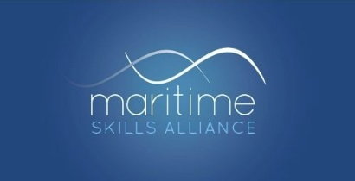

Press Release
Immediate; not embargoed. 12th September 2019
MSA welcomes next steps on the Maritime Skills Commission

The Maritime Skills Alliance is very pleased with the Government’s announcements this week about the Maritime Skills Commission.
Chairman Bill Walworth said:
“This is really good news. The Government has taken on to the next stage the ambitions it set in its Maritime 2050 strategy, so we can start turning those ambitions into real value.
We urged the Department for Transport not to create a wholly new body, and I’m delighted that they’ve listened. The Route Map says that the Commission will build on the foundations laid by Maritime UK’s People and Skills Forum, which I also chair, and I think that’s exactly the right way to proceed.
I’m also very pleased to see the work of the MSA recognised in a commitment that we will be part of the small group charged with shaping the Commission. We are very much looking forward to it, and confident that the Commission will be able to do much more than is currently possible.
We are, of course, also particularly pleased that the funding announcement came at our own reception for London International Shipping Week, the best-attended yet, with around 140 people enjoying a great evening of networking.
ENDS
NOTES TO EDITORS:
The Maritime Skills Alliance is an employer-led body, funded entirely by its 18 members, with no Government contribution. It is unusual in covering the full breadth of the maritime sector, and works to create and promote well-designed qualifications and apprenticeships across the UK. The MSA also convenes Maritime UK’s People and Skills Forum.
The Department for Transport published the People Route Map for Maritime 2050 on 12th September, the third Route Map published to set out how Maritime 2050 will be implemented. DfT committed an initial £300,000 to the Maritime Skills Commission for financial year 2019-20.
The MSA has published three Briefings summarising the announcements on the Maritime Skills Commission, careers and expanding the talent pool.
www.maritimeskills.org

Contact: Iain Mackinnon, Secretary to the Maritime Skills Alliance
0771 424 6740

