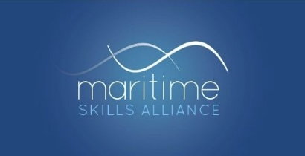

Press Release
Embargoed: 00.01hrs 29th June 2020
Maritime employers pledge their support for apprenticeships

Major employers from across the country’s maritime sector have pledged their support for apprenticeships despite all the pressures resulting from the COVID-19 outbreak. With more and more stories every day of companies making apprentices redundant an initial group of maritime employers - DFDS Ferries, Pendennis Yachts, QinetiQ, the Royal Navy, Serco Marine and Svitzer - have made this commitment:
We pledge to do everything we can to keep our apprentices in their jobs

And with an eye on future, DFDS Ferries, Pendennis Yachts, QinetiQ, the Royal Navy and Serco Marine have made the a second pledge commiting to future recruitment:
We pledge to do everything we can to stick with the next phase of our apprenticeship recruitment programme

Maritime Minister Kelly Tolhurst has congratulated the employers and given her support to the initiative:
The success of our sector relies on its workforce and apprenticeships are a key route into the sector, whether to a career at sea or ashore. It is imperative that we do all we can to preserve and grow our skills base as we look ahead to the sector’s recovery. I am delighted to see the Maritime Skills Alliance launch this initiative and that a number of employers are already pledging their support. I look forward to seeing many more pledge their support and preserve the sector’s apprenticeships offer.

MSA Chairman Bill Walworth explained the background:
We know all the pressures employers are under at the moment, but we also know the value of investing in your future workforce; it’s central to what we do as the Maritime Skills Alliance. We hope that through this initiative more companies will stop and think, take note that others are doing everything they can to protect their investment in people, and ask themselves if they can follow that lead. We hope to see more names added to this list from across the maritime sector – and, who knows, beyond it too.
Gemma Griffin, Vice President HR & Crewing for DFDS Seaways, who chairs the Merchant Navy Training Board’s Apprenticeship Committee, explained why her company signed both pledges:
The strategic imperative hasn’t changed. We started our apprenticeship programme so we get a steady flow of really able people who not only help us run things today, but set us up with the people we’ll need tomorrow. That’s as true now as it every was, despite all that’s happened in the last few months.
We will need to make some adjustments for the next cohort, for sure, and start them a bit later than we originally planned, but we are determined to crack on. We need this to work.
Any company interested in adding its name to either Pledge should contact the Maritime Skills Alliance’s Secretary, Iain Mackinnon, at iain@maritimeskills.org
ENDS
Note to Editors: The Maritime Skills Alliance is an employer-led and owned partnership supporting both its members and the wider sector in creating and promoting qualifications and apprenticeships. It is funded entirely by its members.

Contact: Iain Mackinnon, Secretary to the Maritime Skills Alliance
0771 424 6740
www.maritimeskills.org/Apprenticeships

